Design and Implementation of a Digital Bookkeeping System for Warehouse

A Project Report submitted to the

Department of Computer Science and Engineering, Jahangirnagar University

in partial fulfillment of the requirements for the degree of PMSCS

M.Sc. in Computer Science and Engineering

By

Name: Mohammad Istiaque Hossain

Student Id: CSE201903015

Supervised by

Dr. Md. Ezharul Islam

Associate Professor



DEPARTMENT OF COMPUTER SCIENCE AND ENGINEERING

JAHANGIRNAGAR UNIVERSITY

JANUARY 2022

# **ABSTRACT**

Warehouse is the core component of Supply chain or logistics network. Supply chain or logistics network is a system of organization, people, technology, activities, information and resources involved in moving a product or services from supplier to customer. Supply chain activities transform natural resources, raw materials and components into finished products are delivered to end customer. The products are delivered at the minimum time. This time constraint has a direct impact on warehouse management. Warehousing is one of the stake holders in the supply chain management. Warehouse is the important link between producer and costumer. A warehouse is a location from where raw material, semi-product and finished products are received, transferred or put away, picked, sorted and accumulated, cross-docked and shipped in. Warehouse operation costs account for around 60% of the total cost of an organization. Various factors account for the cost such as labor, material, logistics, sub-costing, etc.

In this Project we aim to develop an Automated Warehouse Management System which optimizes the operations and cost specifically taking into consideration space factor, time factor and cost factor.

In this project the warehouse manager can send order delivery requests there based on need. External suppliers can verify / approve delivery requests by clicking on the secure link in the email notification. Our system automatically allocates space upon receipt of delivery and can similarly find the most convenient product suitable for roll out.

# **DECLARATION**

I, hereby, declare that the work presented in this project is the outcome of the investigation performed by me under the supervision of Dr. Md. Ezharul Islam, Associate Professor, Department of Computer Science and Engineering, Jahangirnagar University, Savar, Dhaka, Bangladesh. I also declare that no part of this Project and thereof has been or is being submitted elsewhere for the award of any degree or diploma.

Countersigned

………………………

Mohammad Istiaque Hossain  
ID: CSE201903015   
Department of Computer Science and Engineering   
Jahangirnagar University   
Savar, Dhaka, Bangladesh.

# **APPROVAL OF ACCEPTANCE**

The Project Report entitled “Warehouse Management System” submitted by Mohammad Istiaque Hossain, ID. No: CSE201903015 to the PMSCS Program, Department of Computer Science and Engineering, Jahangirnagar University, under the supervision of Dr. Md. Ezharul Islam, Associate Professor, Department of Computer Science and Engineering, Jahangirnagar University has been accepted as satisfactory for the partial fulfillment of the requirements for the degree of Master of Science in Computer Science and approved as to its style and contents.

|  |  |
| --- | --- |
| _ _ _ _ _ _ _ _ _ _ _ _ _ _ _ _ Supervisor Dr. Md. Ezharul Islam Associate Professor Department of CSE Jahangirnagar University | _ _ _ _ _ _ _ _ _ _ _ _ _ _ _ _ Supervisor Sarnali Basak Assistant Professor Department of CSE Jahangirnagar University |
|  |  |
|  |  |
|  |  |
|  |  |
|  |  |
|  |  |
|  |  |
|  |  |
| _ _ _ _ _ _ _ _ _ _ _ _ _ _ _ _  Dr. Md. Golam Moazzam Professor  Coordinator, PMSCS Program  Department of Computer Science and Engineering  Jahangirnagar University |  |

# **ACKNOWLEDGEMENT**

I would like to express my special thanks of gratitude to my teacher (Dr. Md. Ezharul Islam, Associate Professor, Dept. of CSE) for his enthusiasm, patience, insightful comments, helpful information, practical advice and unceasing ideas that have helped me tremendously at all times in my research and writing of this thesis. His immense knowledge, profound experience and professional expertise in information technologies has enabled me to complete this research successfully. Without his support and guidance, this project would not have been possible. I could not have imagined having a better supervisor in my study. Who gave me the golden opportunity to do this wonderful project in this regard.

# **LIST OF TABLES**

**ABSTRACT** ii

**DECLARATION** iii

**APPROVAL OF ACCEPTANCE** iv

**ACKNOWLEDGEMENT** v

**LIST OF TABLES** vi

**CHAPTER 1: Introduction** 11

**INTRODUCTION** 11

**CHAPTER 2: Background Technologies and Literature Review** 13

**2. 1** **BACKGROUND** 13

**2. 2** **TECHNOLOGIES** 13

**2. 3** **Literature Review** 15

**CHAPTER 3: Vision and Scope Document for The Warehouse Management System** 19

**3. 1** **PROBLEM STATEMENT** 19

**3.1. 1** **The Problem** 19

**3.1. 2** **The Solution** 19

**3.1. 3** **User Roles** 19

**3. 2** **SOLUTION ATTRIBUTES** 19

3.2. 1 **Vision of the Solution:** 19

**3.2. 2** **Vision statement:** 20

**3.2. 3** **Vision Statement Template:** 20

**CHAPTER 4: System Requirement and Analysis** 21

**4.1** **Types of Requirements** 21

**4.2** **Users** 21

**4.3** **List of Features of the system** 21

**4.4** **Nonfunctional requirements** 22

**4.5** **Operating Environment** 24

**4.6** **Assumptions and Dependencies** 24

**4.7** **Hardware Requirement** 25

**4.8** **Data Requirement** 25

**Chapter 5: System Design** 26

**5.1** **Collecting Data in the Problem Domain** 26

**5.2** **Format of User Story** 26

**5.3** **Data Flow Diagram (DFD) of Users** 27

**5.4** **Use Case Diagram** 28

**5.5** **Database Design** 29

**5.6** **Database Schema Diagram** 29

**5.7** **ER-Diagram** 32

**5.8** **Process Flowchart** 33

**Chapter 6: System Implementation and Evaluation** 35

**6.1.** **System Evaluation** 35

**6.2.** **Hardware Requirement for Implementation** 35

**6.3.** **Target Users and Supported Device** 36

**6.4.** **Code Sample** 36

**6.5.** **Integrate Analytics Tool** 38

**6.6.** **Testing** 39

**6.7.** **Release and Deployment** 39

**6.8.** **Application Screenshots** 39

# **CHAPTER 1: Introduction**

## **INTRODUCTION**

A warehouse management system, also known as WMS, is often used to track any type of inventory. Now some may assume that it is only used for large warehouses where there are thousands of parts, pieces or other products, but this is not entirely true. Although it is used to manage inventory, this WMS has many more capabilities. They streamline everything from ordering, maintenance, removal and interaction with suppliers, distributors. They provide an efficient system that can track the product, no matter how big or small, from the time the parts are ordered to the final delivery to the consumer. Taking the time to understand a little more about the capabilities of a warehouse management system will allow a company to see how much it can do with them!

Warehouse operations play a major role in supply chain management. It ensures the safety of products from the shipping of goods from the plant to the customer during the process. The cost inculcated due to warehouse operations is comparatively high due compared to other operations due to the presence of many non-value-added activities as implied by the present records. The main requirement of the customer is getting the desired goods at a low price, in good condition and on time. Hence, the warehouse operations are optimized in order to meet with the manufacturer and customer perspectives. Generally, warehouse optimization objectives are tried to achieve through warehouse layout design models. Thus, warehouse layout design is important to eliminate inefficiency of warehouse operations and to be cost effective.

Warehouse management system is not a new concept but in the context of Bangladesh it is a very obsolete concept. In our country, people are preferring to using handwritten system over then the automatic system. The main reasons behind this are lack of experience in using the software, high cost of licensing software and common fears about the use of ICT products.

But this situation is changing, almost every one using smart phone and almost every business man know how to operate computer. Here the details regarding this.

**Mobile connections in Bangladesh**

* There were 163.0 million mobile connections in Bangladesh in January 2020.
* The number of mobile connections in Bangladesh increased by 7.0 million (+4.5%) between January 2019 and January 2020.
* The number of mobile connections in Bangladesh in January 2020 was equivalent to 99% of the total population [1]

**Growing laptop market in Bangladesh**

* laptop market in the country was worth $165 million in 2017 and $175 million in 2018.
* IT-based technology product market in Bangladesh is about $1.5 billion.
* Currently 10 lakh laptops are imported every year, with the growth rate between 15% and 20%. [2]

According to the above discussion I strongly consider that WMS can fit across the all type of business, if we provide below feature

* User can add any type of goods of this system for tracking.
* Dynamic dashboard feature for monitoring space and stock.
* Bult-in feature for suppliers’ shipment request automation.
* Easy and Open-source code base for user modification.
* Should be a royalty free software
* Open-source system for updating any feature based on user needs.

# **CHAPTER 2: Background Technologies and Literature Review**

## **BACKGROUND**

The aim of this project is to develop an integrated Warehouse Management System that both administrators and staff can use. The admin will inform suppliers of the requirement of various goods, and staff will be receiving the delivered goods from suppliers also handover the goods. System will be automatically assigned stock pile position at the time of goods receiving. It automatically detects deliverable product location. To make it more user friendly this system should have a dynamic graphical dashboard, where users can see currently available stock position in a graphical representation.

## **TECHNOLOGIES**

This system is developed by using these types of technologies such as

**Client Server Web Application**

Client server web application is of two parts. i.e., client and server. Here server is the central main function. Client requests information from the server. The information that is been updated in the server is distributed to many clients. Many applications rely on client- server model such as world wide web, email, network printing etc., It is client which always initiate communication with servers, which is waiting for the requests. Client does not share any resources, it only requests service from the servers. On the other hand, server host run one or more programs which shares its resources with the clients.

**Front End Development**

Front-end web development, also called client-side development, is the process of creating HTML, CSS, and JavaScript for a website or Web application so that a user can see and interact with it directly [3]. The difficulty with front end development is that the methods and techniques used to design the front end of a website change all the time, possibly requiring the developer's continual awareness of how the field evolves. An individual typically learns HTML, CSS, and JavaScript, which run in a web browser but can also run in a headless browser, Web View, or as compilation input for a native runtime environment.

**JavaScript for the Front End:**

JavaScript is a high-level programming language that is interactive, untyped, and interpreted. It's part of the ECMAScript language specification [4]. It is one of the three basic technologies of World Wide Web content creation, alongside HTML and CSS; it is used by the majority of websites and is supported by all modern web browsers without the need for plug-ins. JavaScript is a multi-paradigm language that supports object-oriented, imperative, and functional programming types, thanks to its prototype-based architecture and first-class functions. It has an API for interacting with text, arrays, dates, and regular expressions, but it lacks I/O features including networking, storage, and graphics, depending on the host environment for these.

**Bootstrap**

Bootstrap is a Cascading Style Sheets (CSS) system that is widely used for front-end prototyping as well as the development of mobile-friendly, reliable websites that are compatible with the majority of browsers. It's also used to build web-based interfaces with a variety of mobile-responsive designs. It makes use of JavaScript (including jQuery), CSS, and HTML. To put it another way, Bootstrap is a grid-based responsive system for developing responsive, mobile-centric projects [5]. The following are some of the advantages that developers appreciate:

1. Quickly create a layout (fixed, fluid, and responsive)
2. Quickly create a form
3. Working grid system
4. Tables
5. Buttons

**Backend with Java Spring**

The first step in building a java backend is to choose a framework. After that, the spring project begins. Build the backend and do backend programming with Java spring. Spring is a platform that helps Java programs to run. Spring includes a number of modules that can be used to create a website. The layout components of Bootstrap are the most important since they influence the entire website.

**Spring Framework**

Spring is a framework that allows developers to decouple each software from the rest of the system. The use of dependency-injection makes swapping components or implementations simpler. Spring provides a framework of ready-to-use modules that are useful for web applications. Spring authentication, for starters, makes access control simple and reliable, and spring data is useful when linking databases. We can use Spring Initialize to start a new spring project. When we first initiate the assistant, we must choose between the project, language, Spring boot versions, dependencies, and project metadata. [6]

**MySQL Database**

A database is a separate application that collects data. Each database has one or more unique APIs that replicate the data it creates, accesses, manages, searches and contains. Other types of data stores can also be used, such as files in filesystems or large hash tables in memory but bringing and writing data to such systems will not be so quick and easy. Nowadays, we use the Relational Database Management System (RDBMS) to store and manage huge amounts of data.

MySQL is a relational database management system based on SQL, a popular language for accessing and managing database records. MySQL is free and open-source software under the GNU license.

**ORM and Spring Data JPA**

In computer science, object-relational mapping is a programming technique for converting data between asynchronous type systems using object-oriented programming languages.

Spring Data JPA, part of the larger Spring Data family, makes JPA-based repositories easier to implement. This module works with enhanced support for JPA based data access levels. This makes it easy to build spring-powered applications that use data access technology.

## **Literature Review**

Warehousing operations takes up to between 2% and 5% of the cost of sales/production of a corporation [7] and with today’s highly competitive global business environment organizations are emphasizing on Return on Assets, so reducing the cost of warehousing has become an important business issue.

To increase productivity and reduce warehouse operation costs, efficient and effective allocation of warehouse resources is required [7]. An important area in determining warehouse efficiency is determining the exact storage location for thousands of products in a warehouse. Various factors affecting storage assignment such as order selection method, size and layout of storage system, material handling system, product characteristics, demand trends, turnover rate and space requirements have been extensively studied. It has been suggested that appropriate storage assignment policies (such as random, dedicated or class-based) and routing methods (such as transversal, return or combined) are a possible solution to improve efficiency related to the above issues [8]. Various decision support models and solution algorithms have also been established to solve warehouse operation planning problems. [9]

The use of information systems for warehouse management has been extensively studied in the literature. The complexity of warehouse management is indicated by the quantity and variety of products handled, the amount of overlap between them, the quantity and type of technology, as well as the characteristics of the associated processes. As complexity increases, it becomes necessary to use warehouse management systems to manage warehouse resources and monitor warehouse activities. Warehouses with a well-processed order line and quantity of stock-keeping units will be best supported by customized software. Using bar-code-based or manual-based warehouse management systems makes it difficult to update real-time inventory levels, forklift locations, and daily activities of stock keeping units (SKUs). [7]

Implementation of Warehouse Management System (WMS) will necessarily provide an increase in accuracy, reduction in labor costs if the labor employed to maintain the system is less than the labor saved on the warehouse floor and a greater ability to service the customer by reducing cycle times. WMS will not only lead in inventory reduction but also in greater storage capacity. An increase in accuracy and efficiency of the receiving process might lead to reduction in level of safety stock required. But the consequence of this reduction will hardly be visible to the overall inventory levels. WMS might just not affect the factors (lot sizing, lead times and demand variability) controlling the inventory levels. However, WMS is instrumental in more efficient and organized that leads to increased storage capacity. [10]

Recently many warehouses management has been published by renowned local and international company. But because of the high price, they are not very popular. There are

1. SAP Warehouse Management
2. Dynamics 365
3. Base Warehouse Management System
4. Pridesys Extended Warehouse Management System

**SAP Warehouse Management**

SAP SE is a German multinational software corporation based in Walldorf, Baden-Württemberg, that develops enterprise software to manage business operations and customer relations. The company is especially known for its ERP software. SAP is the largest non-American software company by turnover. This company have world best Warehouse Management system. But in the context of Bangladesh, it’s a very high price system. Price of this system is more than 3 core in BDT. [11]

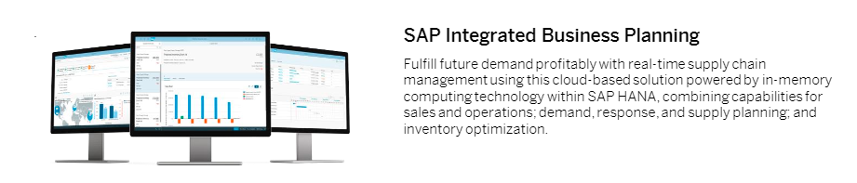

**Figure 1: SAP Warehouse Management**

**Dynamics 365**

Microsoft Dynamics is a line of integrated, adaptable business management solutions that enable the people to make important business decisions with greater confidence. Microsoft Dynamics works like and with familiar Microsoft software-easing adoption and reducing the risks inherent with implementing a new solution. These solutions automate and streamline financial, customer relationship, and supply chain processes in a way that can help drive business success. [12]

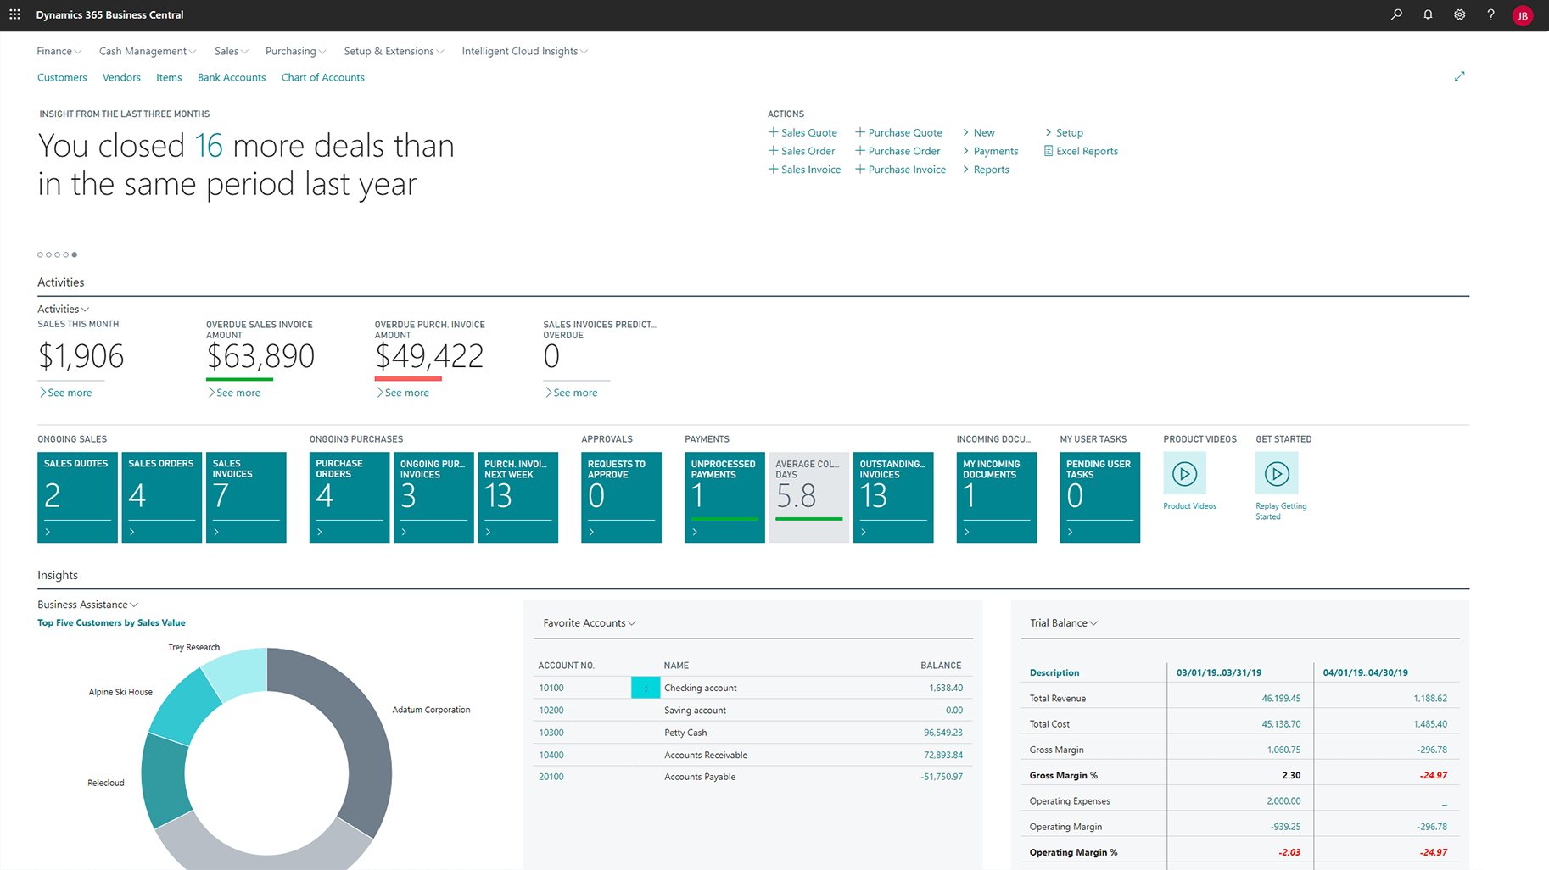

**Figure 2: Dynamics 365**

**Base Warehouse Management System**

This is a software develop locally in Bangladesh. But the company could not fully support it because their marketing policies were not well-received in the local market. The problem with this system is that it sells at very high prices that cannot be used by the root level warehouse owner. The price of this system is 5 lac BDT. [13]

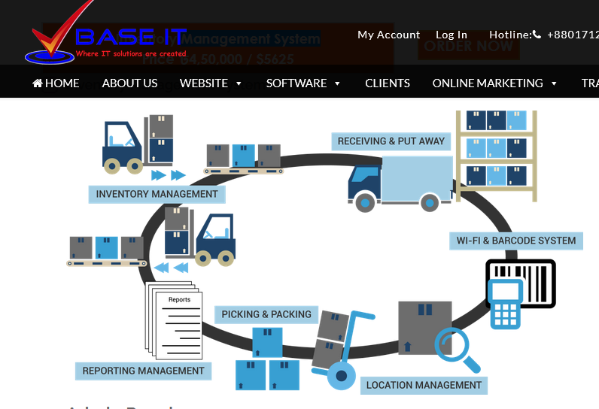

**Figure 3: Base Warehouse Management System**

**Extended Warehouse Management System (EWMS)**

Pridesys Warehouse management system enables and ensure effective inventory control and increase profits by providing greater traceability, recollection management and stock control across the entire supply chain. It’s price also more than 20 lacs. [14]

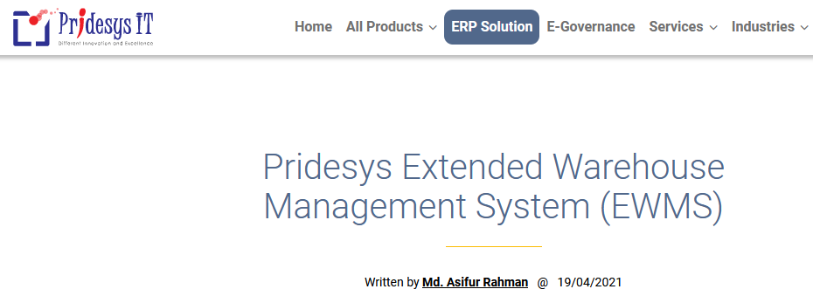

**Figure 4: Extended Warehouse Management System**

# **CHAPTER 3: Vision and Scope Document for The Warehouse Management System**

# **PROBLEM STATEMENT**

### **The Problem**

All types of warehouse management systems are sold at very high prices and the source code in these systems is not open to everyone. So, these cannot be changed according to the needs of the user or change is subject to a lot of cost. Due to the fact that almost all types of software are currently used through the Internet, they cannot be used in areas where the network is very weak. That is why the owners manage the activities by hand, excluding the use of high-cost systems. As the operating costs increase, so work efficiency is also decreasing.

### **The Solution**

A warehouse management system is a digital platform that can make easier for warehouse record keeper’s job. This system aims to improve the quality of all warehouse management services and to encourage its use for fast stock receiving and delivery. This system will provide on-click management information as needed.

### **User Roles**

Three kinds of user roles have to be created for the better accessing end user through the system.



# **SOLUTION ATTRIBUTES**

* For sound knowledge for using this system
  + Participate training
  + Basic knowledge of Supply chine
  + Monitoring dashboard will help to the authority
  + Simple and Clear data entry
* All of these attributes reflect decisions made either by client or by the solution developer

### **Vision of the Solution:**

* Vision of the solution objectives are
* Eliminate Redundant Work
* Data Sharing instantly everywhere
* Increase Accuracy through validation & instruction

### **Vision statement:**

This Applications is passionate about excellence warehouse management where automation system will address to the overall process of the 3 types of user’s engagement through the dedicated features will include such as system can monitor full process.

### **Vision Statement Template:**

The various parts of a general vision statement are:

* For (target user)
* Who (Easer warehouse management system for management)
* The Application is a (digital record keeping a warehouse)
* That (key benefit are automated system and generate revenue through the digital platform)
* Unlike (system can affected virus and database corrupted then alternative way to live the system and database)
* Our product (digitize the warehouse)

**Vision Statement Template**: The vision statement template of this application is

|  |  |
| --- | --- |
| For | All type of warehouse |
| Who | System Admin, Warehouse Manager, Warehouse Staff |
| The Application | Is web base application, need a server to run |
| That | provides the ability to online access the system |
| Unlike | Currently available systems that have poor interface for user not provide a detailed organized system for this purpose. |
| Our product | As a warehouse management system all kinds of features must be address to the system |

Figure 5 Vision statement template

# **CHAPTER 4: System Requirement and Analysis**

## **Types of Requirements**

**Functional requirements**: Describe the interactions between the system and its environment independent from implementation

All requirements of three phases are functional requirements

**Nonfunctional requirements**: User visible aspects of the system not directly related to functional behavior.

**Constraints** (“Pseudo requirements”): Imposed by the client or the environment in which the system will operate

The implementation language must be native java.

## **Users**

1. System Admin
2. Warehouse Manager
3. Warehouse Staff

## **List of Features of the system**

1. Login
2. Logout
3. User list
4. New User
5. Order List
6. New Order list
7. New Category
8. Category lest
9. New Brand
10. Brand List
11. New Product
12. Product List
13. New suppliers
14. Suppliers List
15. Receive List
16. Goods Receive mechanism
17. Goods Delivery List
18. Goods Delivery mechanism
19. Delivery Instruction
20. Visual status of Stock pile
21. Available current stock report

## **Nonfunctional requirements**

In systems engineering and requirements engineering, a non-functional requirement is a requirement that specifies criteria that can be used to judge the operation of a system rather than specific behavior. [15]

**Performance Requirement**

The proposed system that we are going to develop will be used many users in different location in the world. Therefore, it is expected that the database would perform functionally all the requirements.

* The performance of the system should be fast and accurate.
* The system shall handle expected and non-expected errors in ways that prevent loss in information and long downtime period. Thus, it should have inbuilt error testing to identify invalid username/password.
* The system should be able to handle large amount of data. Thus, it should accommodate high number of polls and users without any fault.

**Safety Requirement**

The database may get crashed at any certain time due to virus or operating system failure. Therefore, it is required to take the database backup so that the database is not lost. Proper UPS/inverter facility should be there in case of power supply failure.

**Security Requirement**

* System will use secured database.
* Normal users can just read information, but they cannot edit or modify anything except their personal and some other information.
* System will have different types of users and every user has access constraints.
* Proper user authentication should be provided.
* No one should be able to hack users’ password.
* There should be separate accounts for admin and users such that no user can access the database and only admin has the rights to update the database.

**Requirement attributes**

* There may be multiple admins creating the project, all of them will have the right to create changes to system. But the users or other users cannot do changes.
* The project should be open source.
* The Quality of the database is maintained in such a way so that it can be very user friendly to all the users of the database.
* The user be able to easily download and install the system.

**Business Rules**

A business rule is anything that captures and implements business policies and practices. A rule can enforce business policy, decide, or infer new data from existing data. This includes the rules and regulations that the System users should abide by. This includes the cost of the project and the discount offers provided. The users should avoid illegal rules and protocols. Neither admin nor member should cross the rules and regulations.

**User Requirement**

The users of the system who act as administrator to maintain the system. The members are assumed to have basic knowledge of the computers and internet browsing. The administrators of the system should have more knowledge of the internals of the system and is able to rectify the small problems that may arise due to disk crashes, power failures and other catastrophes to maintain the system. The proper user interface, user manual, online help and the guide to install and maintain the system must be enough to educate the users on how to use the system without any problems.

The admin provides certain facilities to the users in the form of: -

* Backup and Recovery.
* Forgot Password.
* Data migration i.e., whenever user registers for the first time then the data is stored in the server.
* Data replication i.e., if the data is lost in one branch, it is still stored with the server.
* Auto Recovery i.e., frequently auto saving the information.
* Maintaining files i.e., File Organization.
* The server must be maintained regularly, and it must be updated from time to time.

## **Operating Environment**

The product will be operating in browsers, for a model we are taking Microsoft Edge, Google Chrome, Opera, Safari and Mozilla Firefox. Also, it will be compatible with the Microsoft Internet Explorer 11.0 and has an android app version. The only requirement to use this online product would be the internet connection.

## **Assumptions and Dependencies**

The assumptions are: -

* The coding should be error free
* The system should be user-friendly so that it is easy to use for the users
* The information of all users, build must be stored in a database that is accessible by the web application.
* The system should have more storage capacity and provide fast access to the database
* The system should provide search facility and support quick transactions
* The Library System is running 24 hours a day
* Users may access from any computer that has Internet browsing capabilities and an Internet connection
* Users must have their correct usernames and passwords to enter their online accounts and do actions

The dependencies are: -

* The specific hardware and software due to which the product will be run.
* On the basis of listing requirements and specification the project will be developed and run.
* The end users (admin) should have proper understanding of the product.
* The system should have the general report stored.
* The information of all the users must be stored in a database that is accessible by the System.

## **Hardware Requirement**

|  |  |  |
| --- | --- | --- |
| **Description** | **Application** | **Database** |
| Technology | JAVA 1.7 or above | JAVA 1.7 or above |
| Database | MySQL 5 or above | MySQL 5 or above |
| Server Machine for Database | Operating System: windows Server R16 or Any Linux distribution  Minimum Configuration: Processor: Intel® Xeon® Processor E5-4600 Series 10 Core  RAM: 8GB  HDD: 500 GB | Operating System: windows Server R12 or Ubuntu server    Minimum Configuration: Processor: Intel® Xeon® Processor E5-4600 Series 16 Core  RAM: 32 GB ECC DDR3  HDD: 1 TB |
| Development Machine/ Database Server | Operating System: windows 10 or Any Linux distribution    Minimum Configuration: Processor: Core i3 or above RAM: 4GB HDD: 256 GB | Database Server  Operating System: windows Server R12 or Ubuntu server Minimum Configuration: Processor: Intel® Xeon® Processor E5-4600 Series 10 Core  RAM: 32 GB ECC DDR3 HDD: 500 GB |

## 

## **Data Requirement**

The inputs consist of the query to the database and the output consists of the solutions for the query. The output also includes the user receiving the details of their accounts. In this project the inputs will be the queries as fired by the users like create an account, reserve a car. Now the output will be visible when the user requests the server to get details of their account in the form of time, date and which car are reserved.

# **Chapter 5: System Design**

## **Collecting Data in the Problem Domain**

To understand the problem of Car reservation system that we are dealing with, we can adopt the following techniques

* Interview
* Questionnaire
* Experimentation by building a prototype
* Observation
* Document inspection
* User story

## **Format of User Story**

User Story format is chosen for Car reservation system. The format of the User Story is as follows:

* **As a < System Admin>   
   I need <User Control>  
   So that < Control the System>**
  + **As a < Manager>  
     I need <Access to Stock Process>  
     So that <create Stock>**
  + **As a < Staff>  
     I need <Access to Stock IN/OUT process>  
     So that <Done a Job>**

## **Data Flow Diagram (DFD) of Users**

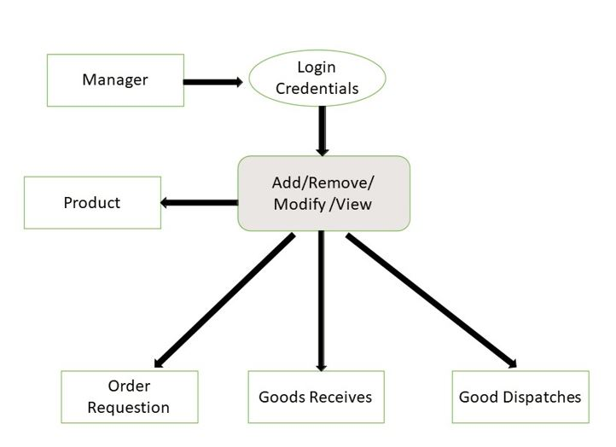

Figure 6 : DFD Diagram of manager in Digital Bookkeeping System for Warehouse

## **Use Case Diagram**

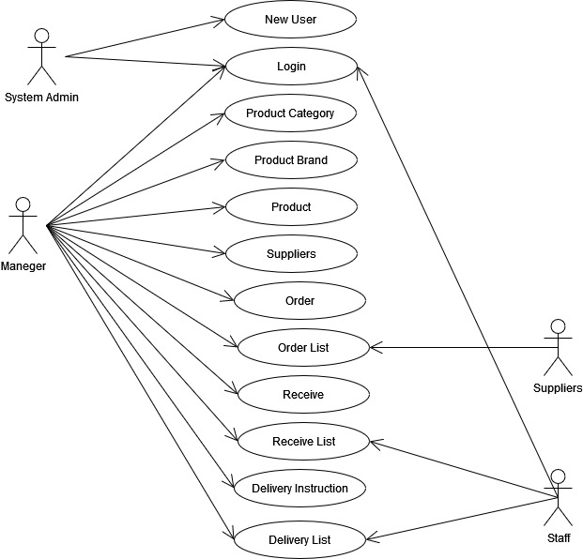

Figure 7: Use case Diagram of Digital Bookkeeping System for Warehouse

## **Database Design**

Database design is the most important part of system design. All activities of users store by using database. As a result, user can access pervious days of activities when developer will use backend database under the system. Various type of decision is taken by using the row data of system.

## **Database Schema Diagram**

**Figure 8 : Database Schema Diagram for Product entry of Automated Warehouse Record Keeping system**

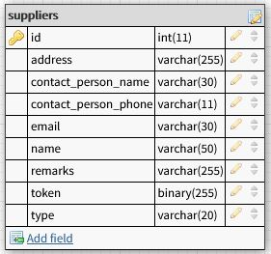

**Figure 9: Database Schema Diagram for Suppliers of Automated Warehouse Record Keeping system**

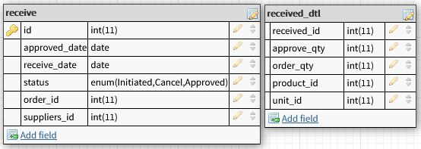**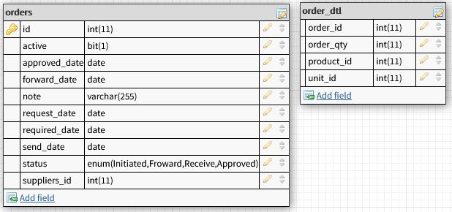Figure 10: Database Schema Diagram for Supply Order of Automated Warehouse Record Keeping system**

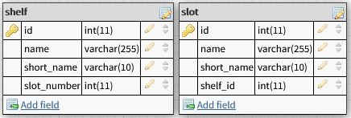**Figure 11: Database Schema Diagram for Product Receive of Automated Warehouse Record Keeping system**

**Figure 12: Database Schema Diagram for Shelf arrangement of Automated Warehouse Record Keeping system**

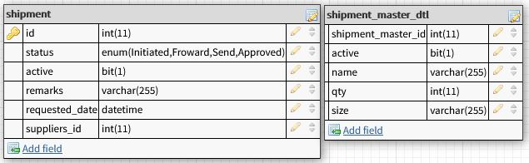

**Figure 13: Database Schema Diagram for Shipment of Automated Warehouse Record Keeping system**

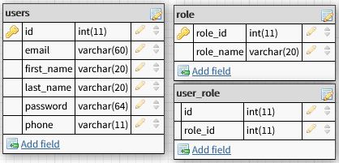

**Figure 14: Database Schema Diagram for User, Role of Automated Warehouse Record Keeping system**

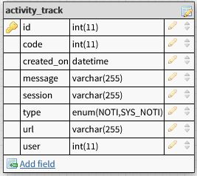

**Figure 15: Database Schema Diagram for Notification of Automated Warehouse Record Keeping system**

## **ER-Diagram**

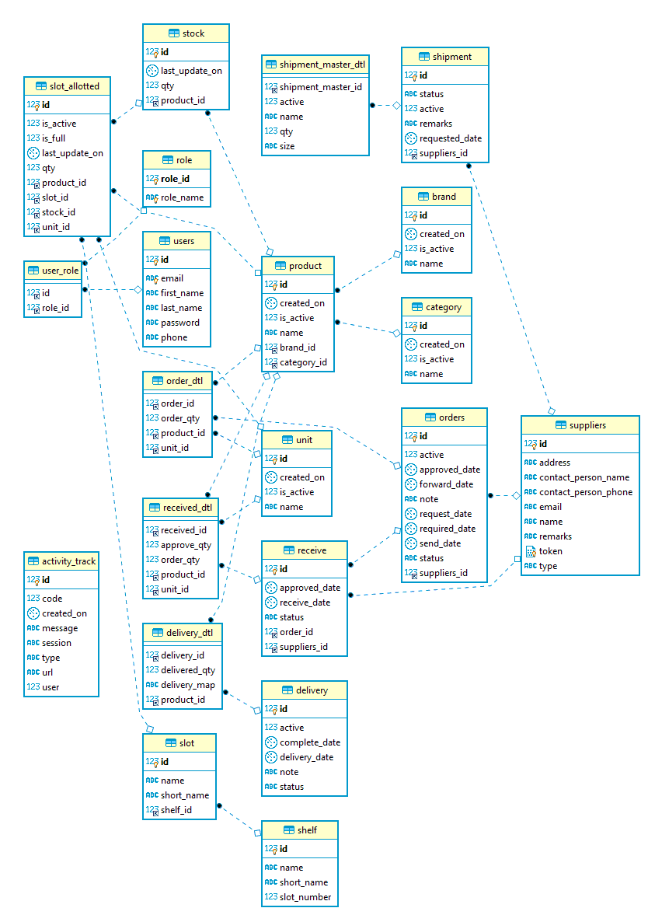

**Figure 16 : ER Diagram of Automated Warehouse Record Keeping system**

## **Process Flowchart**

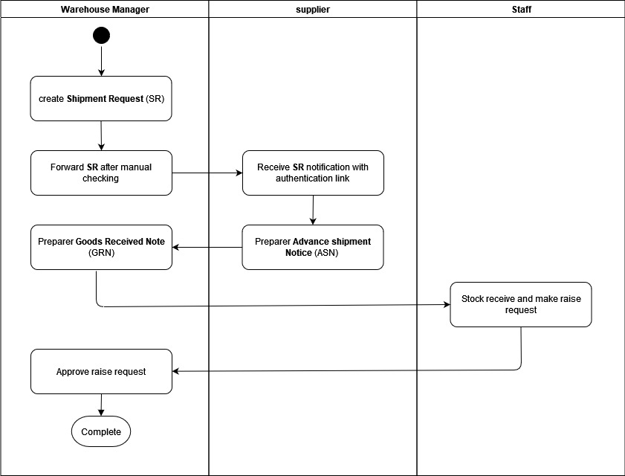

**Figure 17: Work Flowchart for Stock in**

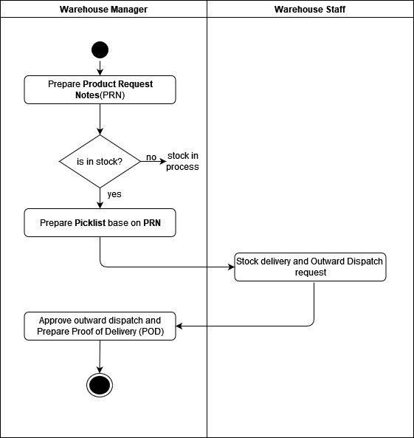

**Figure 18: Flow chart for Stock out**

# **Chapter 6:** **System Implementation and Evaluation**

## **System Evaluation**

Application Idea- A successful application starts with an application idea. To create a successful application, the first thing we need to keep in mind.

Identify a problem which can be resolved by your application- AWRS has developed for the digital platform based on web application. Users will be able to access the platform on any devices (smartphones, tablets, laptop or PC). The user- interface and experience is developed to consider user needs and requirements.

The application should provide customer with tangible benefits including reducing costs via productivity enhancements, new revenue or improving the customer experience.

## **Hardware Requirement for Implementation**

|  |  |  |
| --- | --- | --- |
| **Description** | **Application** | **Database** |
| Technology | JAVA 8 or above | JAVA 8 or above |
| Database | MySQL 5.5 | MySQL 5.5 |
| Server Machine for Database | Operating System: windows Server R16 or Any Linux distribution  Minimum Configuration: Processor: Intel® Xeon® Processor E5-4600 Series 10 Core  RAM: 8GB  HDD: 500 GB | Operating System: windows Server R12 or Ubuntu server    Minimum Configuration: Processor: Intel® Xeon® Processor E5-4600 Series 16 Core  RAM: 32 GB ECC DDR3  HDD: 1 TB |
| Development Machine/ Database Server | Operating System: windows 10 or Any Linux distribution    Minimum Configuration: Processor: Core i3 or above RAM: 4GB HDD: 256 GB | Database Server  Operating System: windows Server R12 or Ubuntu server Minimum Configuration: Processor: Intel® Xeon® Processor E5-4600 Series 10 Core  RAM: 32 GB ECC DDR3  HDD: 500 GB |

## 

## **Target Users and Supported Device**

To create a successful application, you need to identify or be clear about:

* Application target users – An application should always be developed keeping in mind the target users of an application. So, to the application users are customer, driver and Administrator
* All devices to be supported – The product will be operating in browsers, for a model we are taking Microsoft Edge, Google Chrome, Opera, Safari and Mozilla Firefox. Also, it will be compatible with the Microsoft Internet Explorer 11.0 and has an android app version. The only requirement to use this online product would be the internet connection.

## **Code Sample**

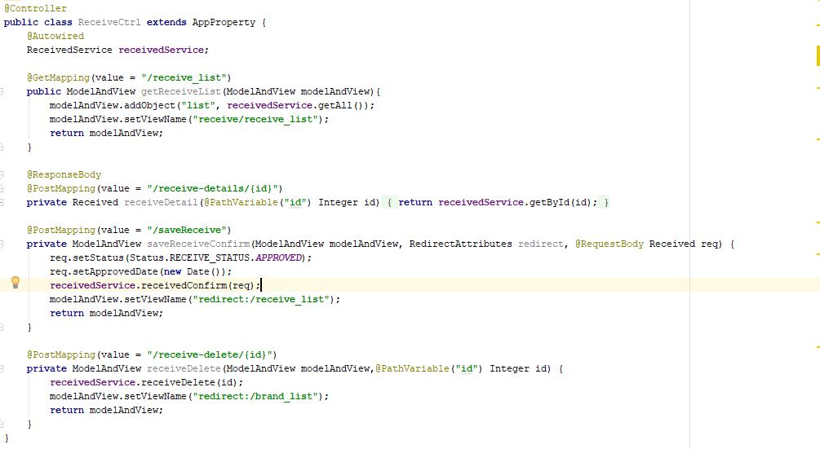

**Figure 19: Product Receive Controller of Automated Recordkeeping system of Warehouse**

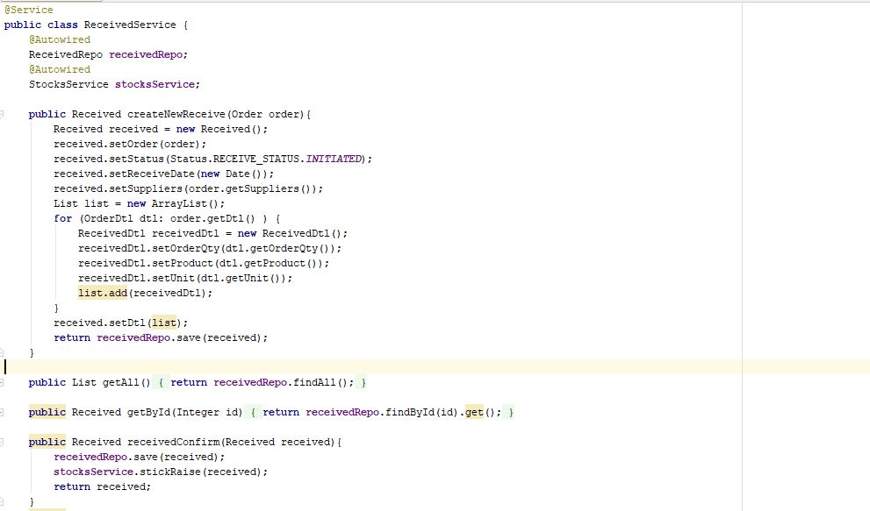

**Figure 20:Product Receiving service code of Automated Recordkeeping system of Warehouse**

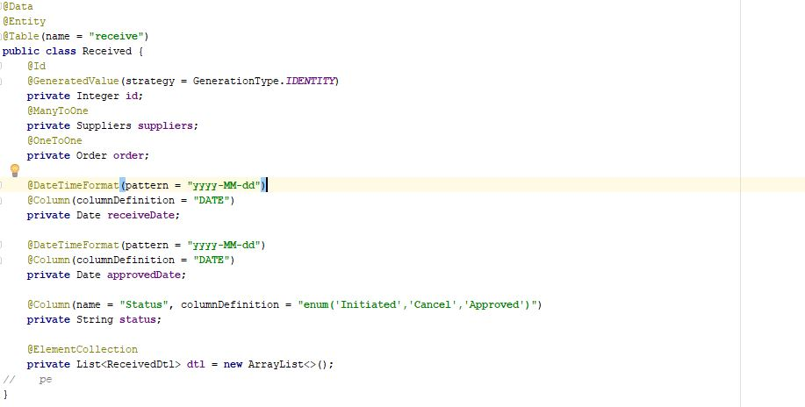

**Figure 21: Model class of Product Receive of Automated Recordkeeping system of Warehouse**

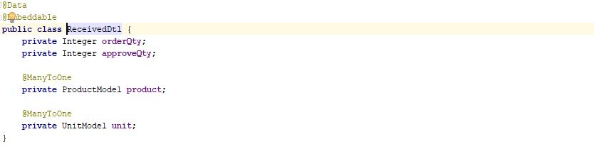

**Figure 22: Model class of Product Receive of Automated Recordkeeping system of Warehouse**

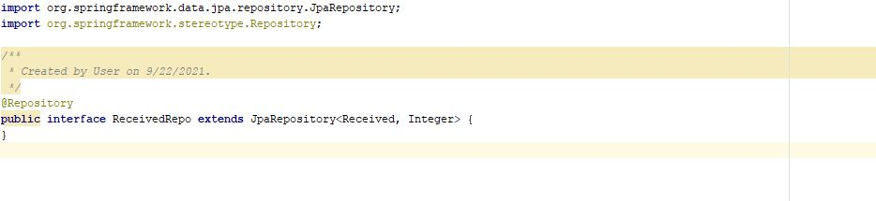

**Figure 23:Repository code of Product Receive of Automated Recordkeeping system of Warehouse**

## **Integrate Analytics Tool**

Basically, this app has 3 users. All user’s functionalities are very from each other. Based on user developed app features and integrated to the main system.

## **Testing**

All feedbacks are incorporated basically these raised from app testing. Given below the overall feedbacks categories

1. UI feedback
2. Feedback based on functionalities.
3. APIs feedback
4. Database level feedback

End Users Feedback: Basically, when I will release this app then end users feedback need to incorporate to the system

## **Release and Deployment**

All web application needs to deploy in a web server. There are a lot of webservers. The JAVA Spring boot web application support cross platform. So, we can deploy the application into Windows, Linux or any Unix server.

## **Application Screenshots**

**Home Page:**

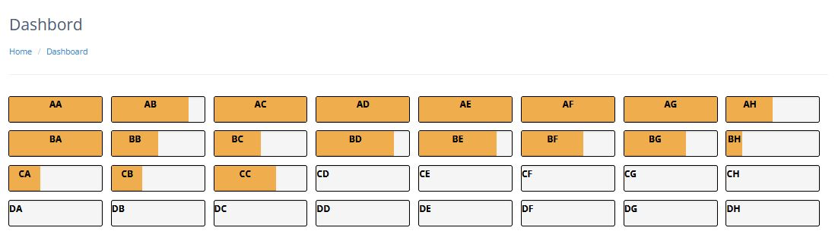

**Figure 24:System home page or Dashboard**

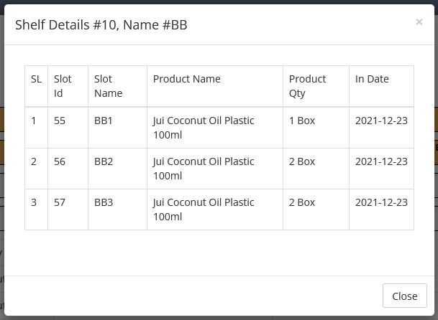**Shelf Details:**

**Figure 25: Shelf Details open from dashboard**

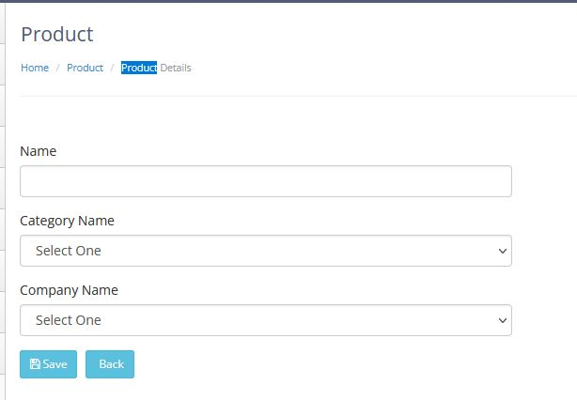**Product Entry Form:**

**Figure 26: New product entry from**

***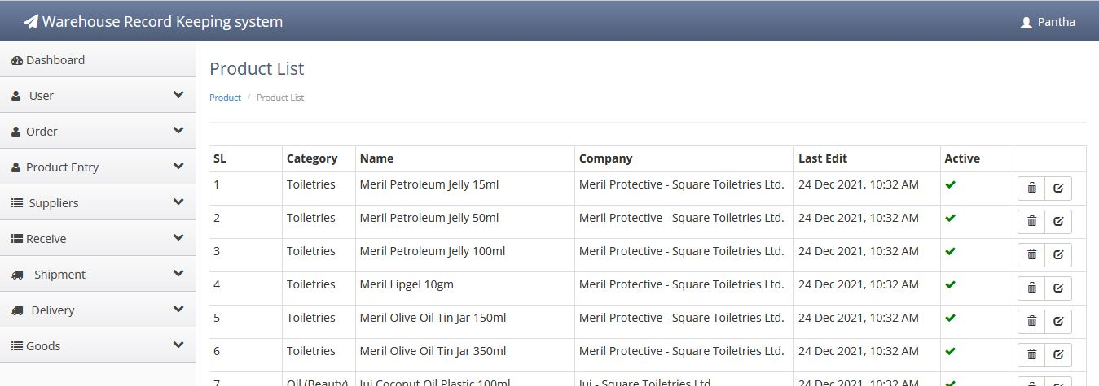*Product List:**

**Figure 27: Product List of the system**

**New Order/ Product Requestion:**

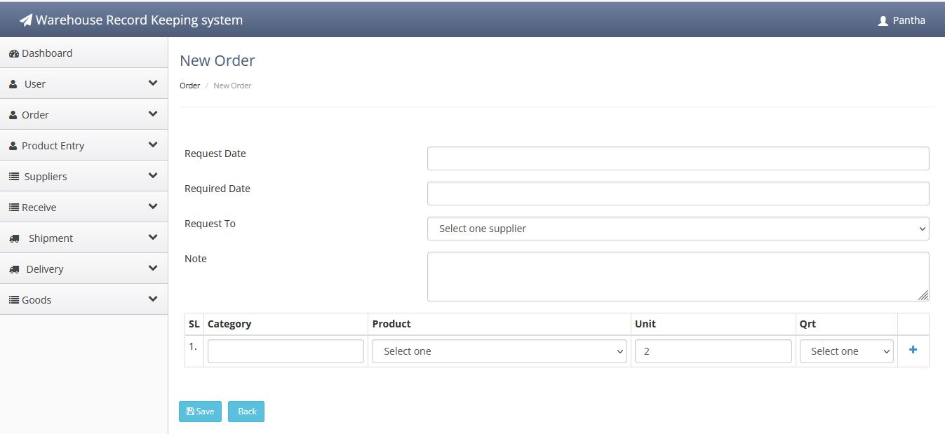

**Figure 28: New Product requestion form**

# **Chapter 7: Consolation and Feature Work**

## **Conclusion**

Warehousing clearly has a critical part to play, in all aspects of supply chain management and smooth internal operation. It also needs to be involved in the strategic aspects of a business and this will involve being aware of the development of the business in terms of the future production, product, suppliers, customers, and all the associated product volumes and throughputs.

Each and every day new technology is being evolved, so in warehousing with the help of these world class technological innovations, we can make it more technically competent and innovative; thereby increasing the efficiency of the business operations.

## **Future Work**

There is many more scope to improve in the application. It’s not possible to improve all the best at the first attempt. In this application also, there are so many scopes to improve. Also, the user experience will be considered.

**Barcode for product tracking:**

In this version of the application, I didn’t implement the Barcode. I have plan to do it the next version.

**Reporting Module:**

In this version of the application, I implement some brief reports. But I have plans to develop a full reporting module in the next version.

**Notification system added to the system:**

The users of the system will get notification based on uses of system. As a result, notify users will able to give quick response about his/her activities.

# References

|  |  |
| --- | --- |
| [1] | "Digital Bangaldesh," https://datareportal.com/reports/digital-2020-bangaldesh, 2020. |
| [2] | "Laptop market thrives on buyers' love for ease," *Dhaka Tribune,* 02 07 2019. |
| [3] | I. Codesido, "What is front-end development?," *Theguardian.com,* 28 Sep 2009. |
| [4] | Mastering Front-End Web Development: 14 Books in 1. Introducing 200+ Extensions. An Advanced Guide, Paperback – Import, 20 November 2020. |
| [5] | M. Otto, Bootstrap 3, USA, New York: Online, 2013. |
| [6] | Spring, The Spring Framework - Reference Documentation, 2021. |
| [7] | D. K. B. M. R. Nynke Faber, "Linking warehouse complexity to warehouse planning and control structure," *An exploratory study of the use of warehouse management information systems.,* Vols. 32,(5), no. Online, p. 381 – 395, 2002. |
| [8] | H. C. Felix T.S. Chan, "Improving the productivity of order picking of a manual-pick and multi-level rack distribution warehouse through the implementation of class-based storage, Expert Systems with Applications," vol. 38(3), p. 2686–2700, 2011. |
| [9] | M. G. L. F. M. Jinxiang Gu, "Research on warehouse operation: A comprehensive review," *European Journal of OperationalResearch,* vol. 177(1), p. 1–21, 2007. |
| [10] | K. C. H. K. C. ,. H. C. L. F. T. C. K. H. T.C. Poon, "A RFID case-based logistics resource management system for managing order-picking operations in warehouses," *Expert Systems with Applications,* vol. 36(4), pp. 8277-8301, 2009. |
| [11] | "Wholesale Distribution," SAP SE, [Online]. Available: https://www.sap.com/india/industries/wholesale-distribution.html. [Accessed 2021]. |
| [12] | "Dynamics 365," Microsoft, [Online]. Available: https://dynamics.microsoft.com/en-us/business-central/signin/. [Accessed 2021]. |
| [13] | "Inventory Management System," Base IT, 2016. [Online]. Available: https://www.baseit.com.bd/inventory-management-system/. [Accessed 2021]. |
| [14] | M. A. Rahman, "Extended Warehouse Mangment System," 19 04 2021. [Online]. Available: https://pridesys.com/inventory-management-software-bangladesh/. [Accessed 2021]. |
| [15] | Wiegers, Karl E., Software Requirements (Second Edition), Microsoft. |